Event Name & Description
Eat at Grazeland

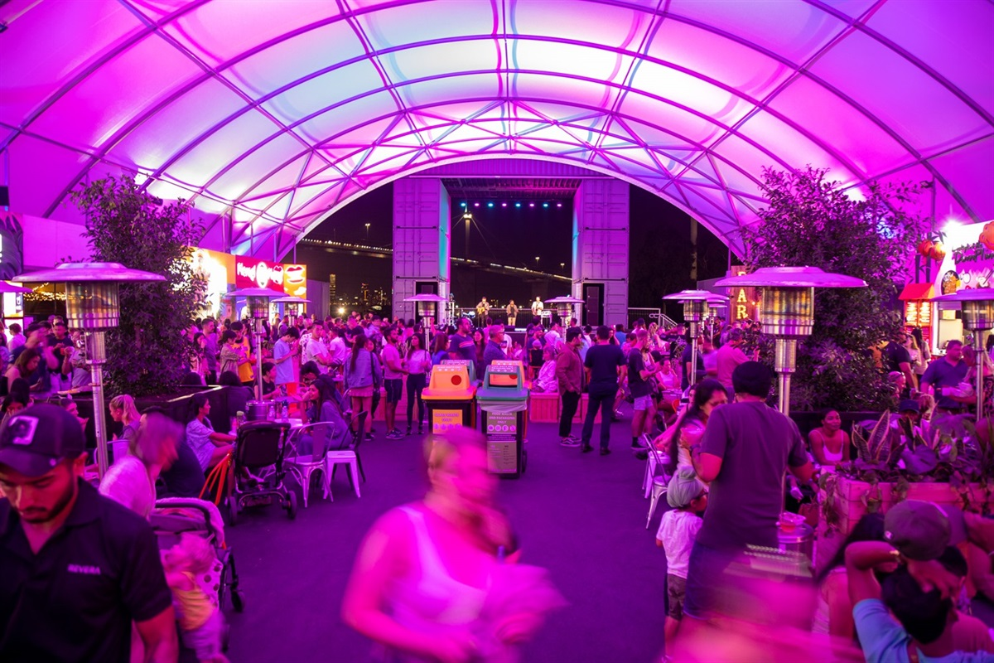

Take a break from the QVM Night Market and head down to the Spotswood with the Iglu crew to enjoy several delicious food and wine options for countless vendors under the roof of Grazeland. Spoil yourself and your tastebuds with some quality cuisine, time and fun. SATURDAY AFTERNOON LUNCH TRIP with Iglu. SIGN UP NOW! LIMITED SPOTS ONLY. Iglu to cover your entry fee!

Event Date | Start Time |  | End Time |  | Estimated Attendance
23/09/23 | 12pm |  | 2pm |  | 20
RL(s) Hosting Event |  | Other Staffing Requirements |  | Estimated Staff Hours
Abir |  | - |  | 2.5HRS

Budget Summary
Revenue Item | Income
Fundraising Goal | $0
Expense Item | Cost
Shopping (See list over) | $80
Transport (See details over) | $0
Other Expenses (see list over) | $0
Total Estimated Cost | $80
Health & Safety
Event Type | ☐ Onsite (Cooking) | ☐ Onsite (non-cooking) | ☒ Offsite (establishment) | ☐ Offsite (outdoors)
Relevant Risks | ☐ Burns | ☐ Physical injury | ☒ Travel risk | ☐ Travel risk
 | ☐ Cuts/laceration | ☐ Burns | ☒ First aid | ☐ First aid
 | ☐ Manual Handling | ☐ Cuts/laceration |  | ☐ Weather
 | ☐ Distraction | ☐ Chemicals |  | ☐ Drowning
 | ☐ Food safety | ☐ Manual Handling |  | ☐ Missing person

Event Communication Plan
(what / when / how / responsibility / due)
What – A food trip to Grazeland Melbourne. Entry fee into the festival is AUD 4pp. Iglu to cover that for each attending resident. Max of 20 residents. Residents to buy their own food/drink inside the venue. Iglu group to sit together inside.

https://www.grazeland.melbourne/

The various food and drink options at Grazeland can be viewed here - https://www.grazeland.melbourne/food-and-drink

When – 23/09/23 12PM- 2PM (LUNCH)

Where - 20 Booker St, Spotswood
Melbourne 3015

How and Responsibilities - RL will put out a sign-up sheet on 04/09/23.
RL will buy tickets once residents have paid and send them a confirmation text on the same day.

RL will send out pre-event texts to residents about departure time.

RL will lead the group to the venue and coordinate entry.

Residents are free to stay for as long as they want and do not have to come back with the RL.

Transport Requirements |  | Other Expenses
List public transport route details and times |  | Prizes, Equipment hire, other Purchase items
Walk to Southern Cross Station
PTV Train towards Williamstown
Get off at Spotswood Station
Walk to Grazeland
Cost | Myki charges | Cost | $0

Shopping List
Item | Unit Price | Qty | Total Price
Entry Ticket | 4 | 20 | 80
 | TOTAL |  | 80

Task List
Item | Due Date | Responsibility
Create Sign-up Sheet | 04/09 | RL
Pre-Event Texts | 22/09 | RL
Lead group to venue | 23/09 | RL
Coordinate entry into venue | 23/09 | RL
Debrief, Photos, EAL | 24/09 | RL

